Inheritance 3

Simulations
Programs regularly used to simulate real world activities: e.g.: city traffic; the weather; nuclear processes; stock market fluctuations; environmental impacts; space flight.
They are often only partial simulations and they often involve simplifications.
- Greater details has the potential to provide greater accuracy
- Greater detail typically requires more resource:
  - Processing power
  - Simulation time

Benefits:
- Support useful prediction.
  - e.g., the weather.
- Allow experimentation.
  - Safer, cheaper, quicker.

Predatory-prey simulations
There is often a delicate balance between species.
- A lot of prey means a lot of food.
- A lot of food encourages higher predator numbers.
- More predators eat more prey.
- Less prey means less food.
- Less food means...

The foxes and rabbits project

Classes of interest
- Fox
  - Simple model of a type of predator.
- Rabbit
  - Simple model of a type of prey.
- Simulator
  - Manages the overall simulation task.
  - Holds a collection of foxes and rabbits.

Modelling the environment
- Field
  - Represents a 2D field.
- Location
  - Represents a 2D position in the environment.

Monitoring the simulation
- SimulatorView
  - Represents a view of the environment.
- FieldStats, Counter
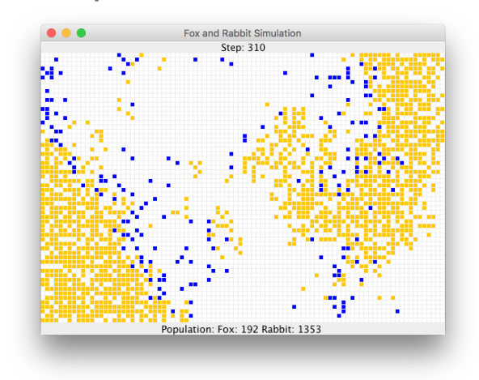
  - Maintain statistics.
- Randomizer
  - Supports reproducibility.

Source code

Rabbit - state
public class Rabbit
{
static fields omitted
// Individual characteristics (instance fields).
private int age;
private boolean alive;
// The rabbit’s position
private Location location;
// The field occupied
private Field field;
Methods omitted.
}

Rabbit – behaviour
- Managed from the run method.
- Age incremented at each simulation ‘step’.
  - A rabbit could die at this point.
- Rabbits that are old enough might breed at each step.
  - New rabbits could be born at this point.

Rabbit – simplifications
- Rabbits do not have different genders.
  - In effect, all are female.
- The same rabbit could breed at every step.
- All rabbits die at the same age.

Fox – State
public class Fox
{
static fields omitted
// Individual characteristics (instance fields).
private int age;
private boolean alive;
// The rabbit’s position
private Location location;
// The field occupied
private Field field;
// The fox’s food level, which is increased
// by eating rabits.
private int foodLevel;
Methods omitted.
}

Fox – behaviour
- Managed from the hunt method.
- Foxes also age and breed.
- They become hungry.
- They hunt for food in adjacent locations.

foxes
- Similar simplifications to rabbits
- Hunting and eating could be modelled in many different ways.
  - Should food level be additive?
  - Is a hungry fox more or less likely to hunt?
- Are simplifications ever acceptable?

The simulator class
- Three key components:
  - Setup in the constructor.
  - The populate method.
    - Each animal is given a random starting age.
  - The simulateOneStep method.
    - Iterates over separate populations of foxes and rabbits.
    - Two field objects are used: field and updateField.

The update step
for(Iterator<Rabbit> it = rabbits.iterator(); it.hasNext(); ) {
Rabbit rabbit = it.next();
rabbit.run(newRabbits);
if (! rabbit.isAlive()) {
it.remove();
}
}
...
for(Iterator<Fox> it = foxes.iterator(); it.hasNext(); ) {
Fox fox = it.next();
fox.hunt(newFoxes);
if(! Fox.isAlive()) {
it.remove();
}
}

Improving the project
Fox and Rabbit have strong similarities but do not have a common superclass.
- The update step involves similar-looking code.
- The Simulator is tightly coupled to specific classes.
  - It ‘knows’ a lot about the behaviour of foxes and rabbits.

The animal superclass
- Place common fields in Animal: age, alive, location
- Method renaming to support information hiding: run and hunt become act.
- Simulator can now be significantly decoupled.

Revised (decoupled) iteration
for(Iterator<Animal> it = animals.iterator(); it.hasNext();) {
Animal animal = it.next();
animal.act(newAnimals);
// Remove dead animals from simulation
if (! animal.isAlive()) {
it.remove();
}
}

The act method of animal
- Static type checking requires an act method in Animal.
- There is no obvious shared implementation.
- Define act as abstract:
abstract public void act(List<Animal> newAnimals);

Abstract classes and methods
Abstract methods have abstract in the signature.
- Abstract methods have no body.
- Abstract methods make the class abstract.
- Abstract classes cannot be instantiated.
- Concrete subclasses complete the implementation.

Simulation with inheritance

The animal class
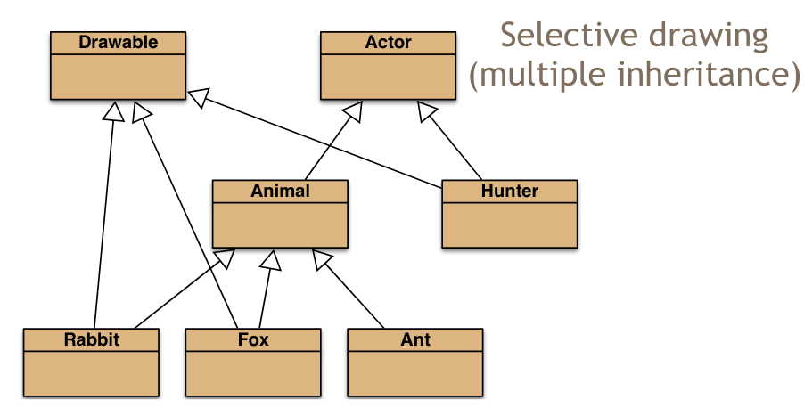
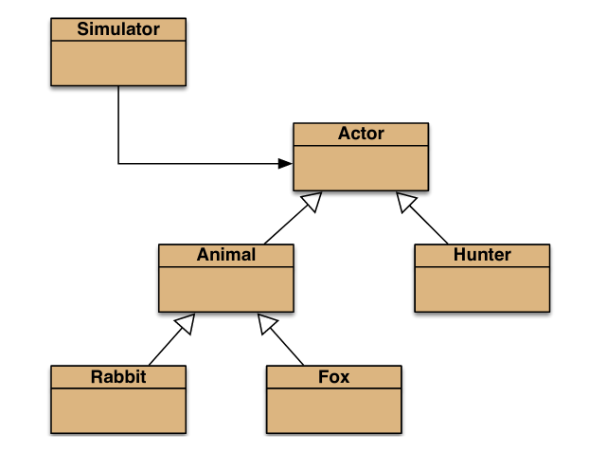
public abstract class Animal
{
fields omitted
/**
* Make this animal act – that is: make it do
* whatever it wants/needs to do.
*/
abstract public void act(List<Animal> newAnimals);
other methods omitted
}

Multiple inheritance
Having a class inherit directly from multiple ancestors.
- Each language has its own rules.
  - How to resolve competing definitions?
- Java forbids it for classes.
- Java permits it for interfaces.

Interfaces

An actor interface
public interface Actor
{
/**
* Perform the actor’s regular behaviour
* @param newActors A list for storing newly created
* actors.
*/
void act(List<Actor> newActors);
/**
* Is the actor still active?
* @return true if still active, false if not.
*/
boolean isActive();
}

- Classes implement an interface.
public class Fox extends Animal
implements Drawable
{
...
}

public class Hunter
implements Actor, Drawable
{
...
}

Interfaces as types
- Implementing classes are subtypes of the interface type.
- So, polymorphism is available with interfaces as well as classes.

Features of interfaces
Use interface rather than class in their declaration.
- They do not define constructors.
- All methods are public.
- All fields are public, static and final (those keywords may be omitted)
- Abstract methods may omit abstract.

- Methods marked as default have a method body – they are not abstract.
- Methods marked as static have a method body.
- Default and static methods could complicate multiple inheritance of interfaces.

Default methods
Introduced in Java 8 to adapt legacy interfaces; e.g. java.util.List.
- Classes inheriting two with the same signature must override the method.
- Syntax for accessing the overridden version:
InterfaceType.super.method(…)

Interfaces as specifications
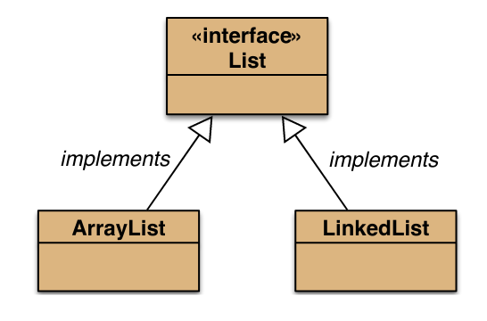
- Strong separation of functionality from implementation.
  - Though parameter and return types are mandated.
- Clients interact independently of the implementation
  - But clients can choose from alternative implementations.
- List, Map and Set are examples.

